**Jenkins Task-2**

Create a simple script file and push it to repo. Create a project in Jenkins connected to your GitHub repository. When a commit is made to your repo, automatically build must get triggered from Jenkins and the output must be shared to me via email.

**Git Repo Script Screenshot**

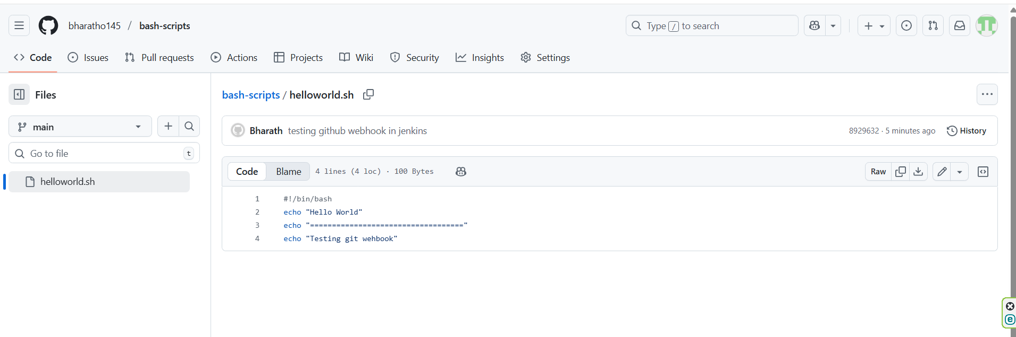

**Jenkins Job Configuration and Mail Configuration Screenshot**

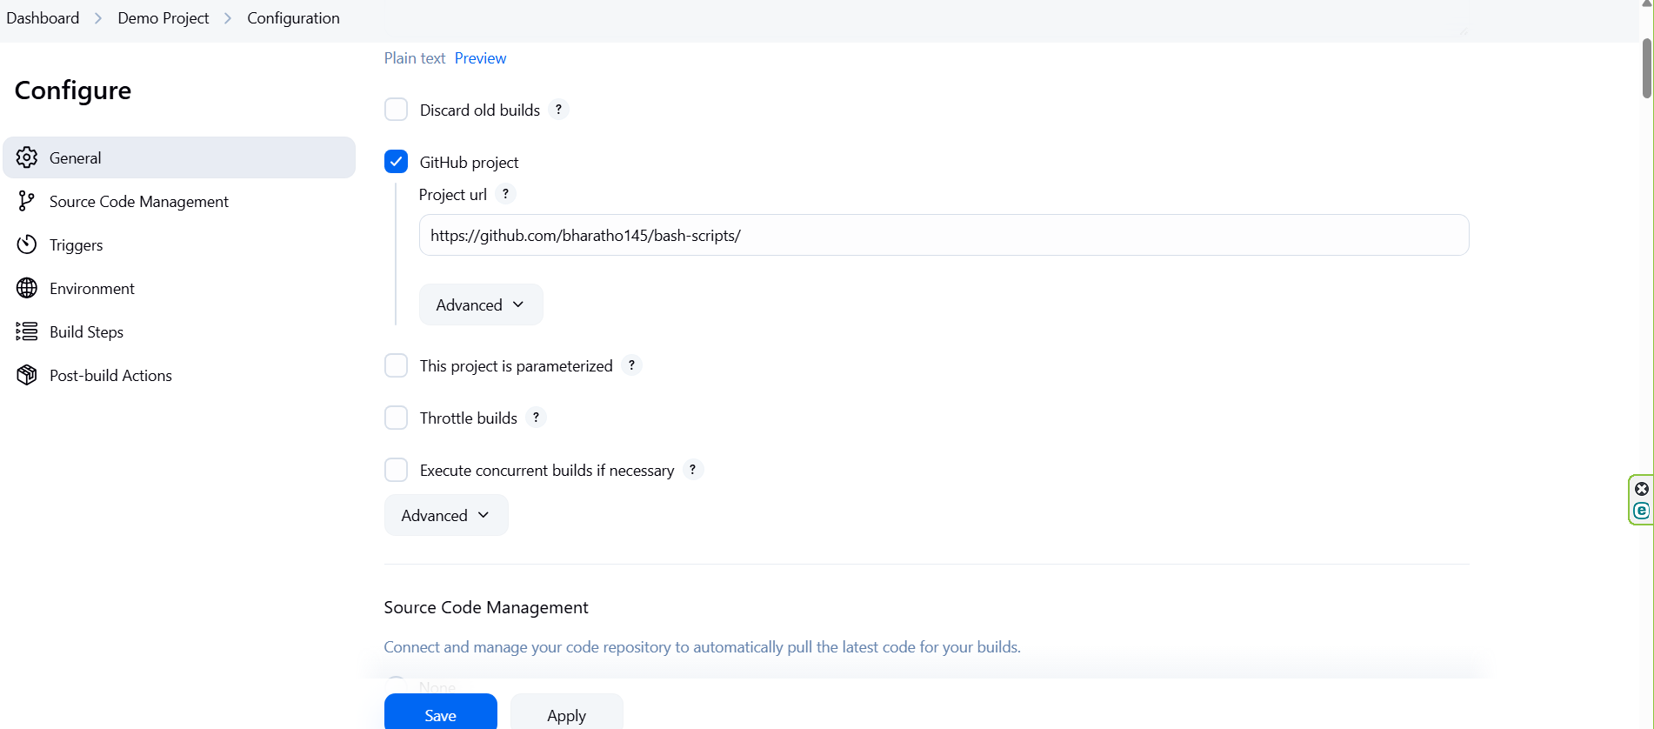

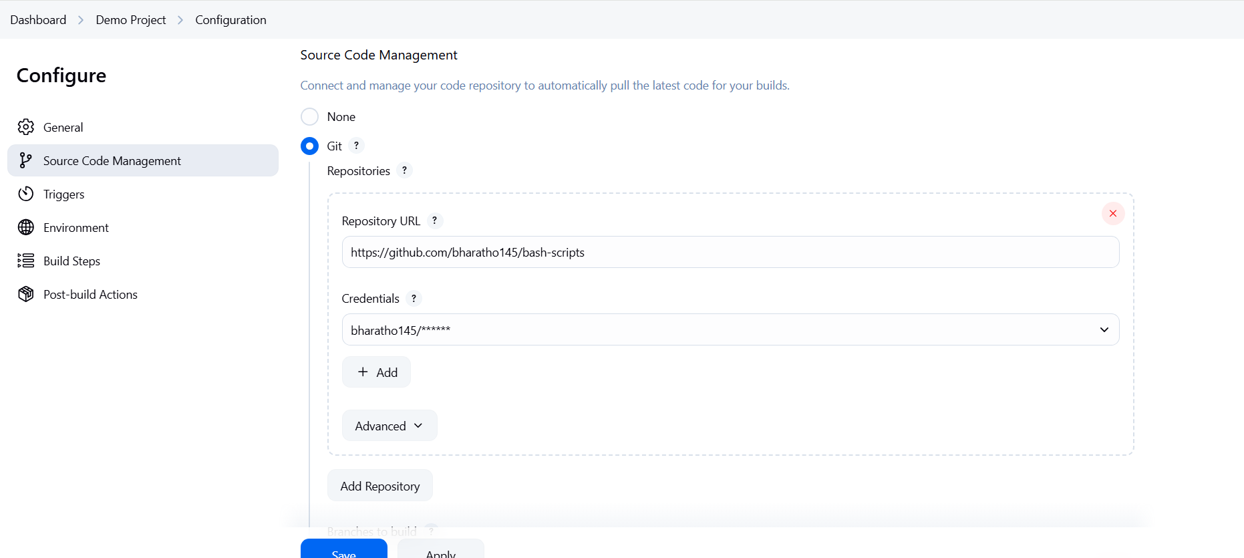

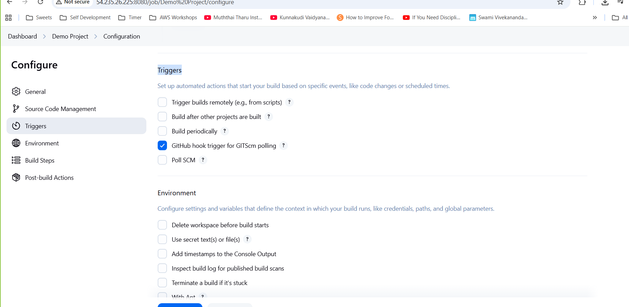

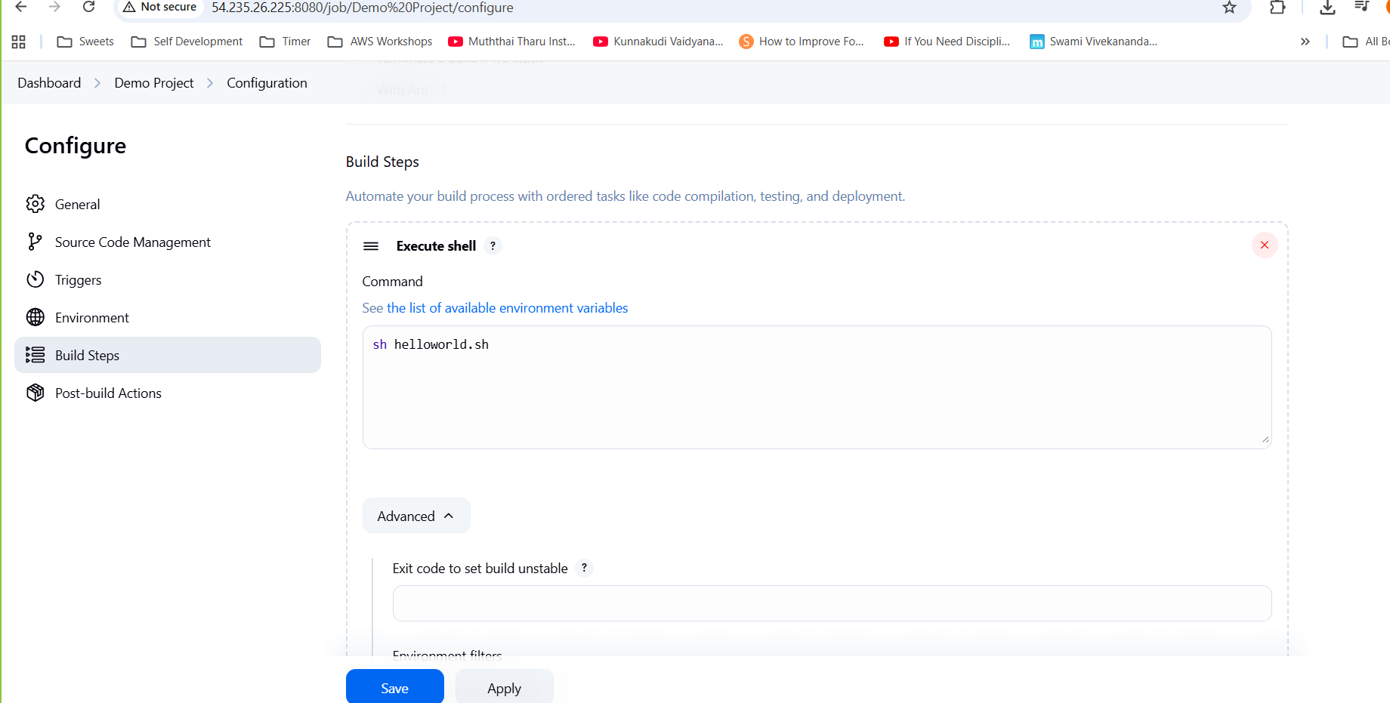

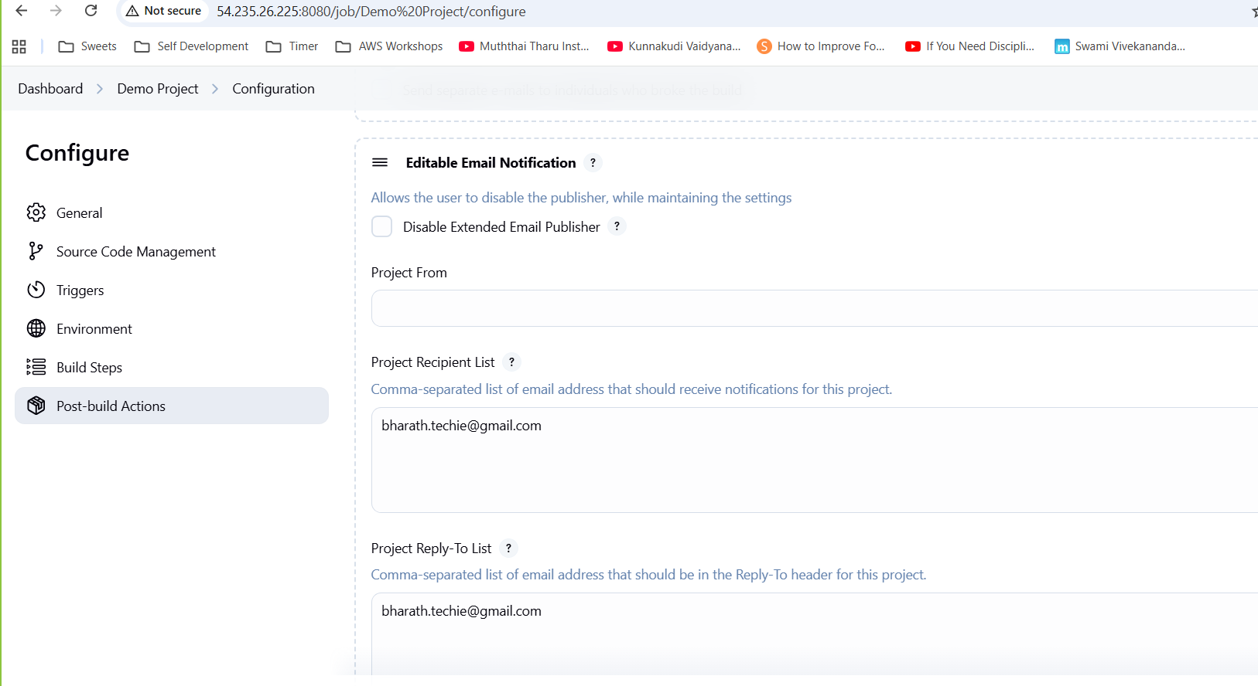

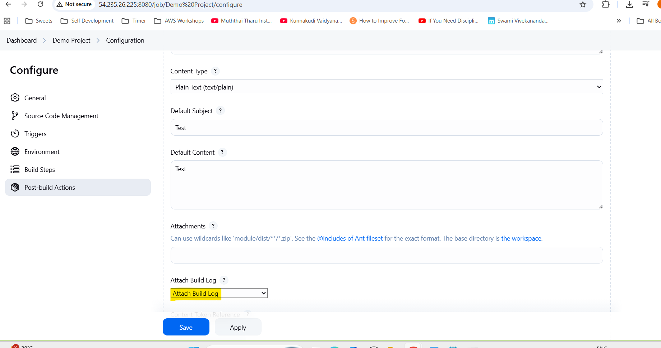

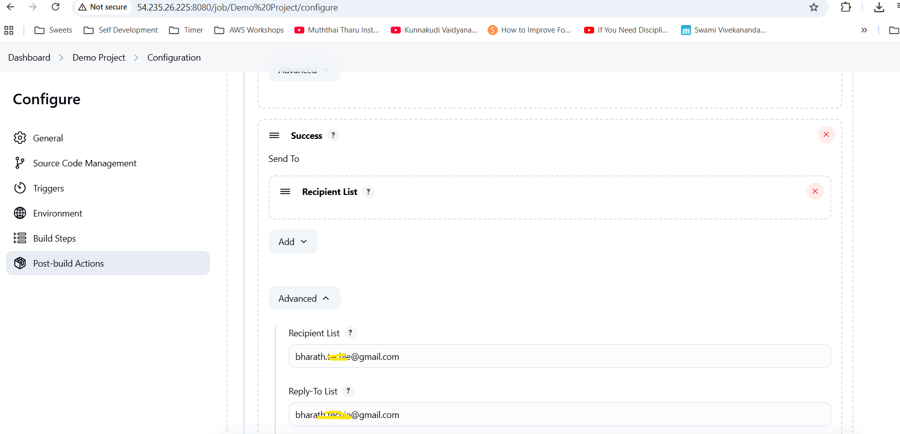

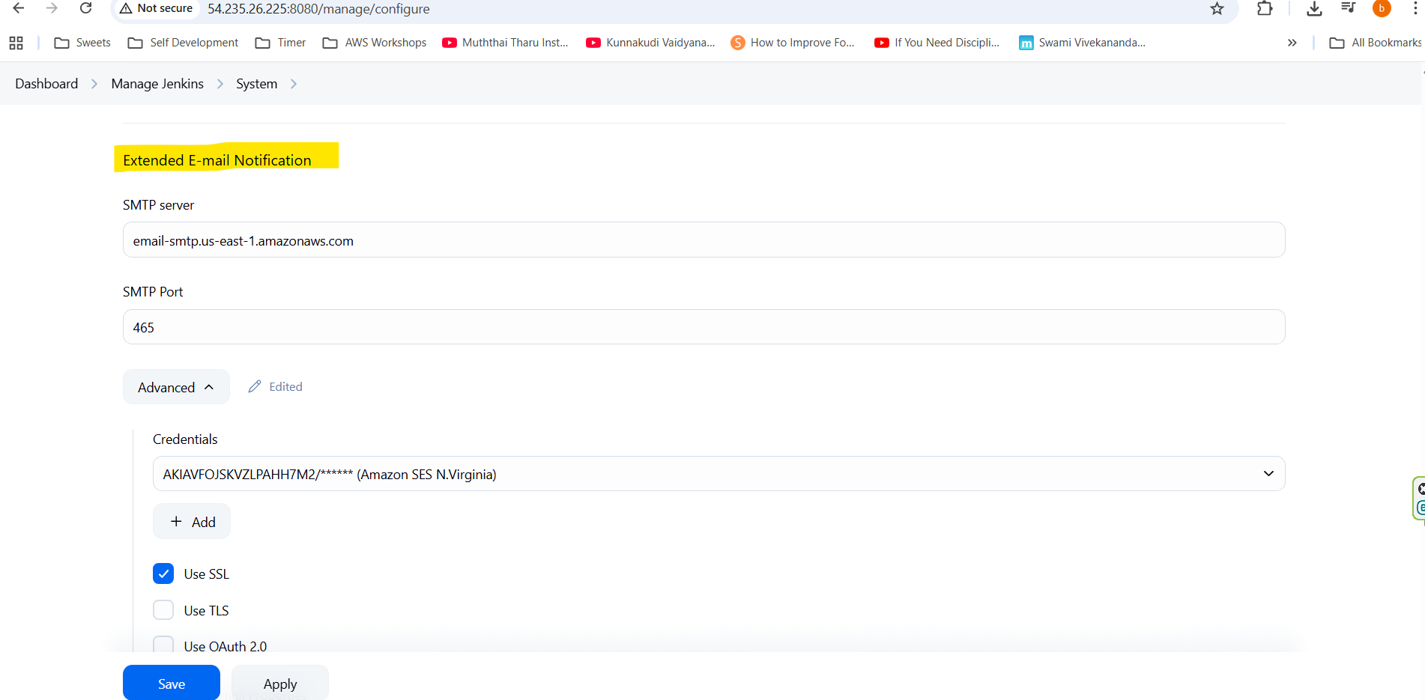

**Configuring Webhook**

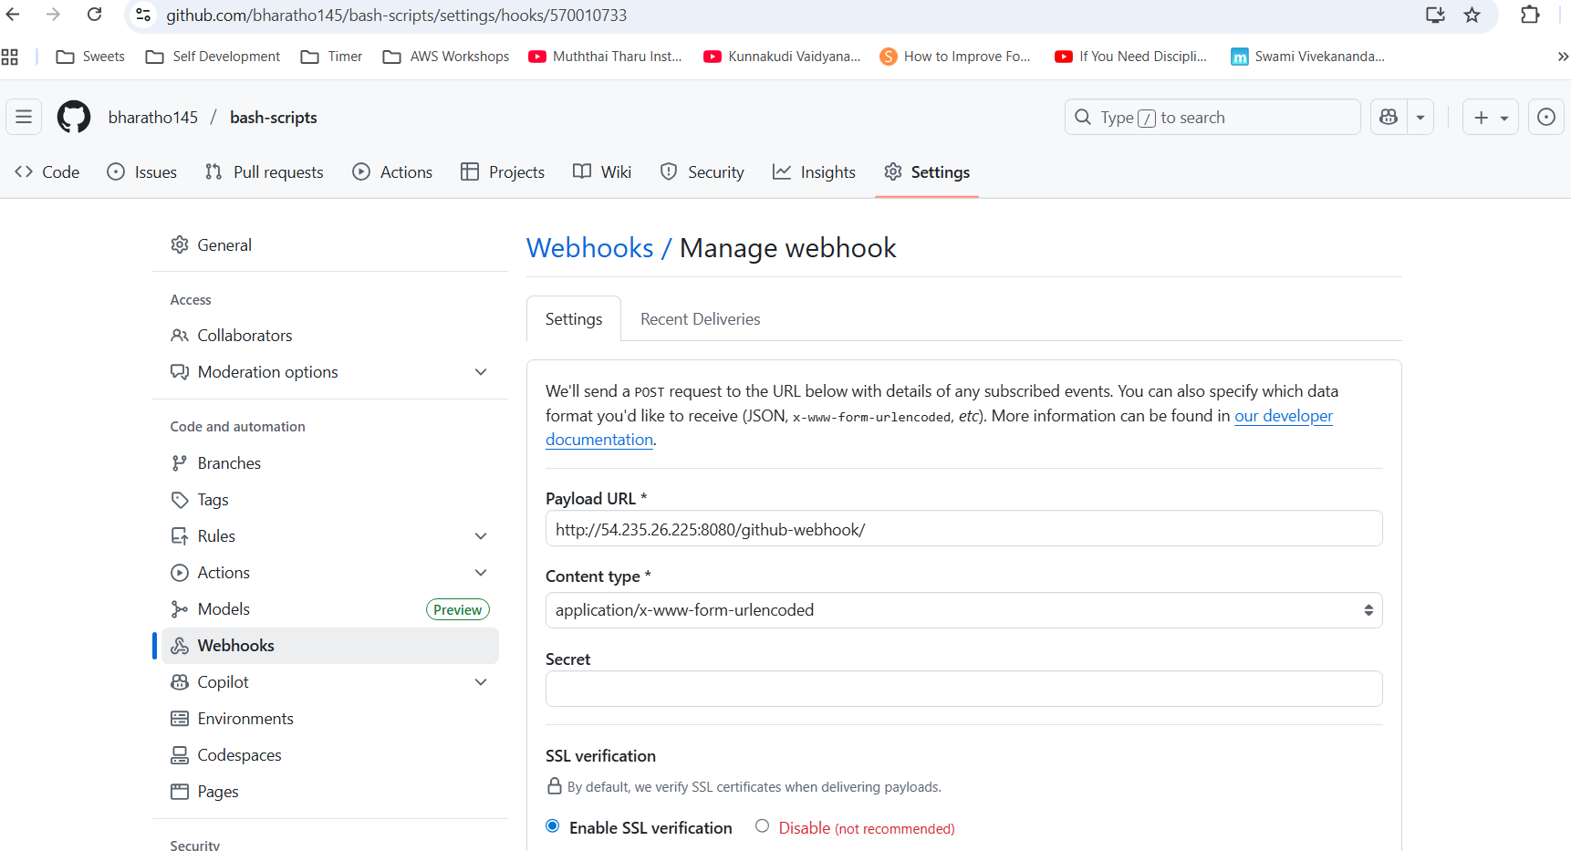

**Email Screenshot**

